QUESTION 1:

public class empsalary

{

public static void main(String[] args)

{

Scanner sc=new Scanner(System.in);

double wage=sc.nextDouble();

int hour=sc.nextInt();

int no_week=sc.nextInt();

double total;

if(hour>40)

{

total=(40*wage)+(hour-40)*wage*1.5;

}

else

{

total=wage*hour;

}

if(hour<20)

{

total=total*(10/100);

}

double salary=total*no_week;

System.out.println("Total Salary: "+salary);

}

}

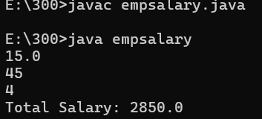

QUESTION 2:

import java.io.*;

import java.util.Scanner;

public class tic

{

public static void main(String[] args)

{

Scanner scan=new Scanner(System.in);

String t=scan.nextLine();

int n=scan.nextInt();

double total=0.0;

switch(t){

case "Regular":

if(n>10)

total=n*50*0.90;

else

total=n*50;

if (total<200)

total=total+20;

break;

case "VIP":

if(n>5)

total=n*100*0.85;

else

total=n*100;

if (total<200)

total=total+20;

break;

case "Premium":

if(n>3)

total=n*150*0.80;

else

total=n*150;

if(total<200)

total=total+20;

break;

default:

System.out.println("Invalid input");

break;

}

System.out.println(total);

}

}

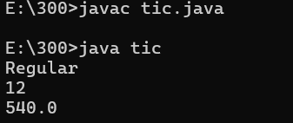

QUESTION 3:

import java.util.Scanner;

import java.io.*;

public class cse

{

public static void main(String[] args)

{

Scanner scan=new Scanner(System.in);

int n=scan.nextInt();

int l=Integer.MIN_VALUE;

int s=Integer.MAX_VALUE;

while(n!=0)

{

int digit=n%10;

if(digit>l)

{

l=digit;

}

if(digit<s)

s=digit;

n=n/10;

}

System.out.println(s+" "+l);

}

}

